
University of Azad Jammu & Kashmir
Department of Software Engineering

Program: | BS-CET
Course: | Database Applications
Submitted To: | Engr. Dr. Asma javaid
Submitted By: | Samama Iqbal
Roll Number: | 2024-CET-08

Introduction

This lab report documents the practical implementation of fundamental Database Application concepts using XAMPP, MySQL, and phpMyAdmin. The tasks cover the complete lifecycle of setting up a local database environment — from installing the required software stack to creating databases, managing users, designing tables, and performing data manipulation operations.
Step 1 Install XAMPP & Open phpMyAdmin

Install the XAMPP server stack on a local machine, start Apache and MySQL services, and access the phpMyAdmin web interface via browser.
Steps:
- Download XAMPP from https://www.apachefriends.org and run the installer.
- Open the XAMPP Control Panel after installation.
- Click Start next to the Apache module to launch the web server.
- Click Start next to the MySQL module to start the database service.
- Open any web browser and navigate to: http://localhost/phpmyadmin
- The phpMyAdmin dashboard loads, confirming the environment is ready.

XAMPP Control Panel (Apache & MySQL Running)
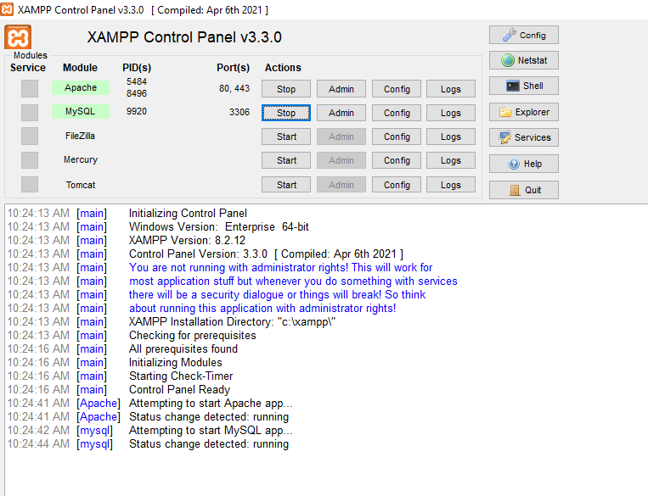

phpMyAdmin Dashboard in Browser
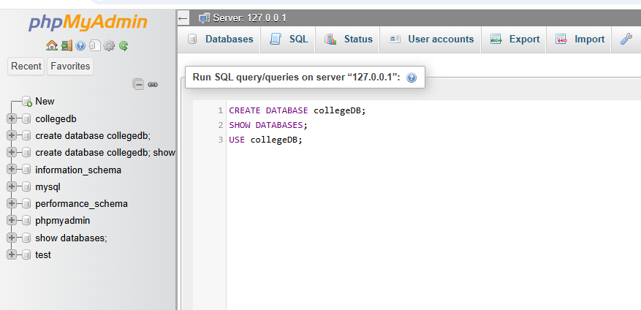

Step 2 Create Database

Create a new database named collegeDB using SQL commands, verify its creation, and switch into it for subsequent operations.

SQL Commands Executed
-- Create a new database
CREATE DATABASE collegeDB;

-- Verify the database was created
SHOW DATABASES;

-- Switch to the new database
USE collegeDB;

Command | Description
CREATE DATABASE collegeDB; | Creates a new empty database named collegeDB on the MySQL server.
SHOW DATABASES; | Lists all existing databases — used to confirm collegeDB was created.
USE collegeDB; | Selects collegeDB as the active database for all subsequent queries.


Output of CREATE DATABASE & SHOW DATABASES

Step 3 Create User & Grant Privileges

Create a dedicated MySQL user account named student1 with a password, and grant all privileges on the collegeDB database to that user.

SQL Commands Executed
-- Create a new MySQL user
CREATE USER 'student1'@'localhost' IDENTIFIED BY '12345';

-- Grant full privileges on collegeDB to student1
GRANT ALL PRIVILEGES ON collegeDB.* TO 'student1'@'localhost';

Command | Description
CREATE USER 'student1'@'localhost' | Creates a user named student1 allowed to connect from localhost only.
IDENTIFIED BY '12345' | Sets the login password for this user account.
GRANT ALL PRIVILEGES ON collegeDB.* | Grants every privilege (SELECT, INSERT, UPDATE, DELETE, etc.) on all tables inside collegeDB.
TO 'student1'@'localhost' | Specifies which user account receives the privileges.

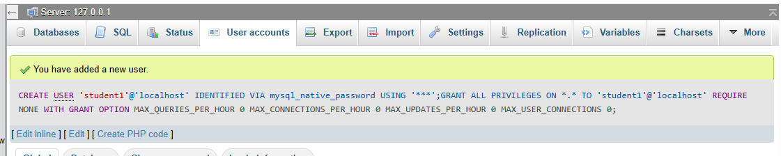
User Created & Privileges Granted

Step 4 Create Students Table

Design and create the Students table with appropriate column definitions inside collegeDB, then verify its structure using SHOW TABLES and DESC commands.

SQL Commands Executed
-- Create the Students table with 3 columns
CREATE TABLE Students (
ID INT PRIMARY KEY,
Name VARCHAR(50),
Age INT
);

-- Verify the table exists in the database
SHOW TABLES;

-- Display the table structure/schema
DESC Students;

Column Name | Data Type | Constraint | Description
ID | INT | PRIMARY KEY | Unique numeric identifier for each student; cannot be NULL or duplicate.
Name | VARCHAR(50) | None | Student full name — variable-length string up to 50 characters.
Age | INT | None | Student age stored as a whole number (integer).

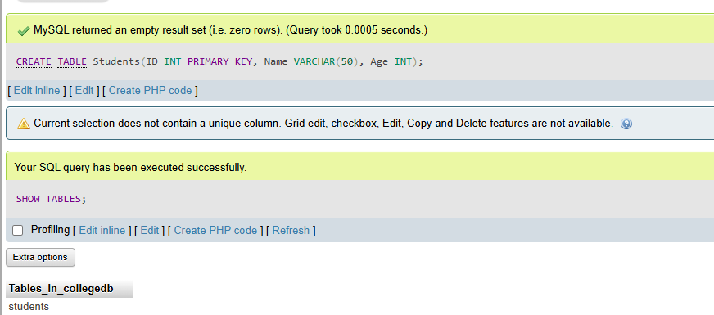
SHOW TABLES Output

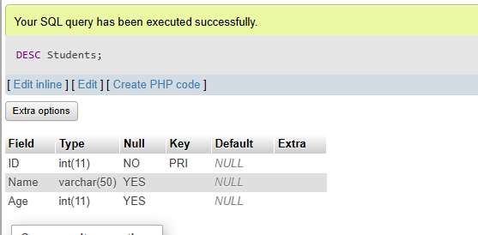
DESC Students (Table Structure)

Step 5 Insert & Query Data

Insert two student records into the Students table using INSERT INTO statements, and retrieve all records using a SELECT query to verify the data was stored correctly.

SQL Commands Executed
-- Insert first student record
INSERT INTO Students VALUES (1, 'Fatima', 20);

-- Insert second student record
INSERT INTO Students VALUES (2, 'Umama', 22);

-- Retrieve all records from the table
SELECT * FROM Students;

Statement | Purpose
INSERT INTO Students VALUES (...) | Adds a new row of data into the Students table in the specified column order.
SELECT * FROM Students | Retrieves and displays ALL columns and ALL rows from the Students table.

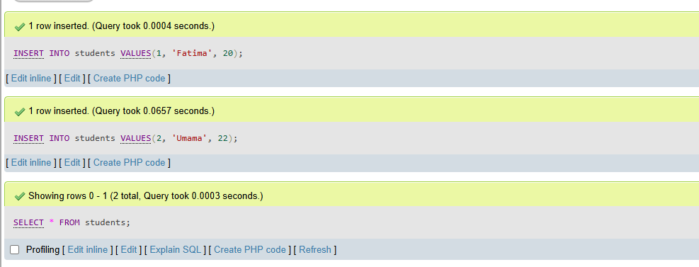
INSERT & SELECT Output (phpMyAdmin / MySQL CLI)
